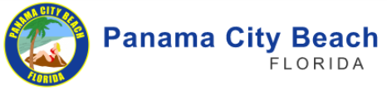

City of Panama City Beach has partnered with DemandStar an online marketplace connecting local governments with an extensive network of suppliers across Florida and nationwide. DemandStar is open and accessible to all businesses. DemandStar gives you instant access to RFPs, bids, quotes, and other opportunities with the City of Panama City Beach
By registering for a complimentary account with DemandStar, you get Instant Access to bids for the Village of Biscayne Park. Your free DemandStar account provides:
- Instant access to all bid and quotes for the City of Panama City Beach
- Automatic notifications from the City of Panama City Beach - right to your inbox
- The ability to quickly view the contractual terms and scope of work
- All the forms and documents you need in one place.
It’s EASY! Get started with these 3 easy steps!

 | REGISTER  Go to www.demandstar.com/registration | 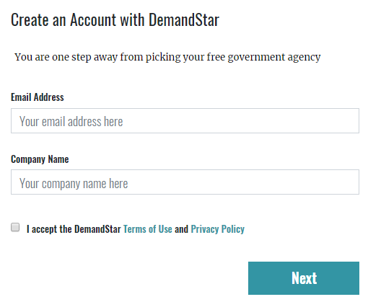
 | CHOOSE YOUR FREE AGENCY  Type “City of Panama City Beach” in the Search Box | 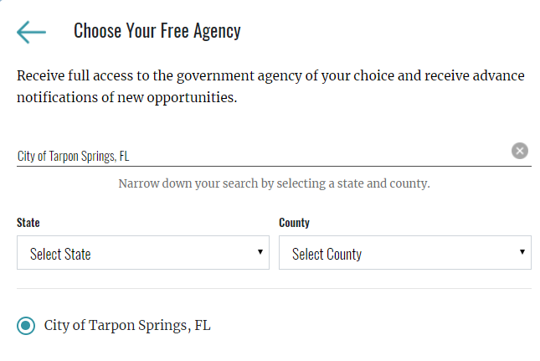
 | CHECK OUT  Check out with your FREE AGENCY Registration by clicking “Skip for now” on the page where it gives you options to add additional counties and States. DemandStar is free for SUPPLIERS, so you don’t have to pay for access you just need to choose “City of Panama City Beach” on the free agency page. | 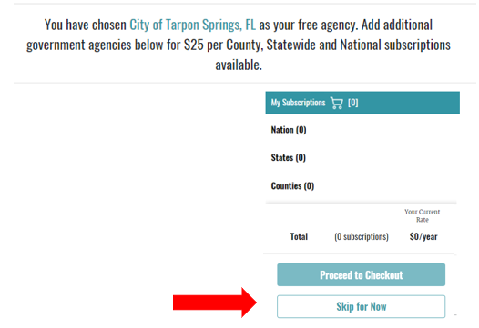

Visit www.demandstar.com

